Promotion – Programme Committee & EES Table members

LinkedIn

🌍 Registration and abstract submission for NWO NAC 2027 are now open!
The Earth and Environmental Sciences community will come together on 18 & 19 March 2027 at NH Conference Centre. NWO NAC is the annual scientific conference for researchers across the Earth and environmental sciences in the Netherlands. By Connecting Spheres across disciplines, research and society, we create space for new ideas, perspectives and collaborations. Connect with colleagues, stay on top of the latest developments in the field and collect inspiration for your own research.
This year, researchers have helped shape the programme by proposing a wide range of parallel session themes. To give as many proposed sessions as possible the opportunity to become part of the final programme, the Programme Committee will base its final selection on the contributions submitted by the community.
There are several ways to contribute:
Oral and poster abstract
Deadline: 4 December 2026
Demo submission
Showcase a tool, technique, method or research application
Deadline: 3 February 2027
By submitting your work, you not only share your research with the community, but also help shape the final conference programme and determine which parallel session themes will be featured at NWO NAC 2027.
Registration is also open now and remains open until 17 February 2027.
More information, registration and abstract submission: https://nwonac.nl/registration-and-abstracts
We look forward to welcoming you to NWO NAC 2027!

Mailing
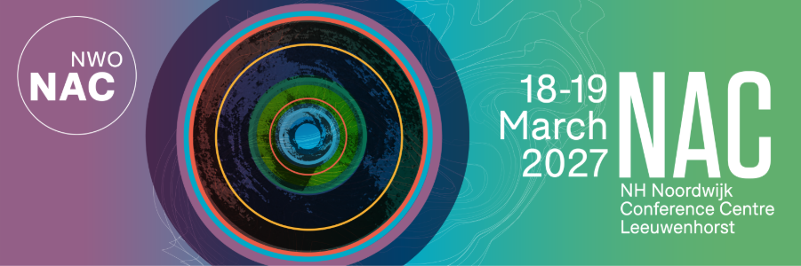
Subject: Registration and abstract submission for NWO NAC 2027 are now open
Dear [colleague],
We are pleased to announce that registration and abstract submission for NWO NAC 2027 are now open.
NWO NAC 2027 will take place on 18 & 19 March 2027 at NH Conference Centre Leeuwenhorst. NWO NAC is the annual scientific conference for researchers across the Earth and environmental sciences in the Netherlands. By Connecting Spheres across disciplines, research and society, we create space for new ideas, perspectives and collaborations. Connect with colleagues, stay on top of the latest developments in the field and collect inspiration for your own research.
This year, the community has played an active role in shaping the scientific programme. The call for parallel sessions resulted in a large number of proposed themes, reflecting the breadth and diversity of research within our field.
To give as many proposed sessions as possible the opportunity to become part of the final programme, the Programme Committee has decided to include them in the abstract submission process. Following the abstract deadline, the Committee will make a final selection of parallel sessions based on the submitted contributions and the level of interest from the community.
We therefore invite you to contribute your work to NWO NAC 2027 through one of the following formats:
Oral and poster abstract
Present your latest research during a thematic session.
Deadline: 4 December 2026
Demo submission
Demonstrate a tool, technique, method or research application to a broad audience.
Deadline: 3 February 2027
In addition, registration for the conference is now open.
Registration deadline: 17 February 2027
Whether you are presenting new research, showcasing an innovation or looking to engage with colleagues from across the Earth and Environmental Sciences, we encourage you to join us at NWO NAC 2027.
More information, registration and abstract submission: https://nwonac.nl/registration-and-abstracts
We look forward to receiving your contribution and welcoming you in March 2027.
Kind regards,
Programme Committee NWO NAC 2027
Team NWO NAC 2027

